Streamlit

streamlit hello

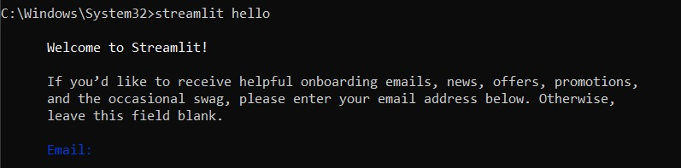

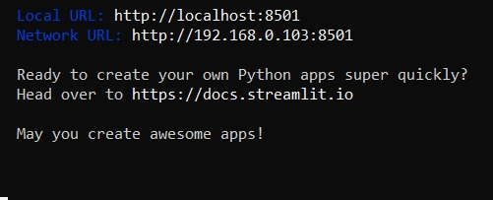

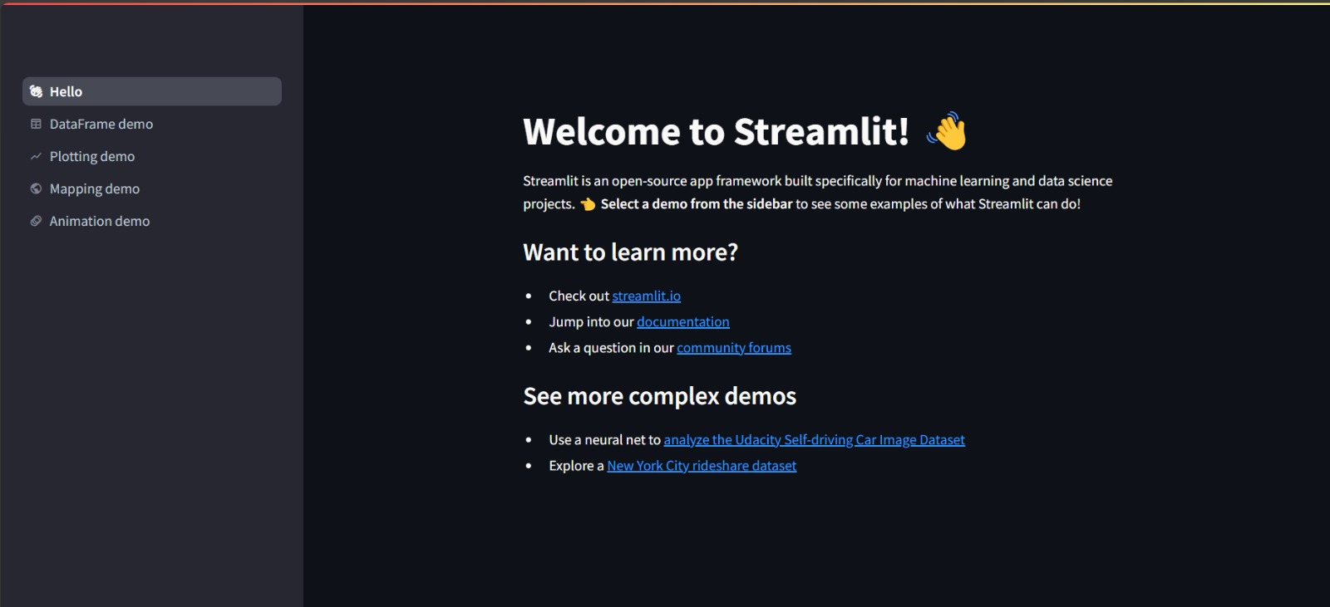

Creating a venv in python : python -m venv myvenv

cd myvenv

cd Scripts

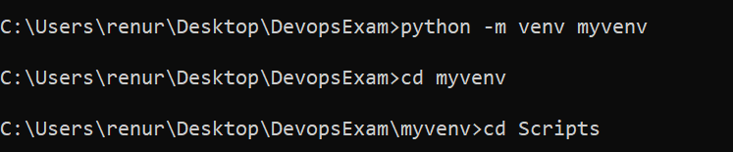

activate

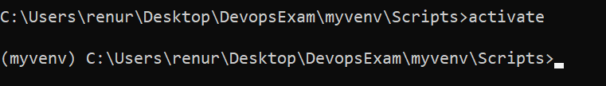

pip install streamlit

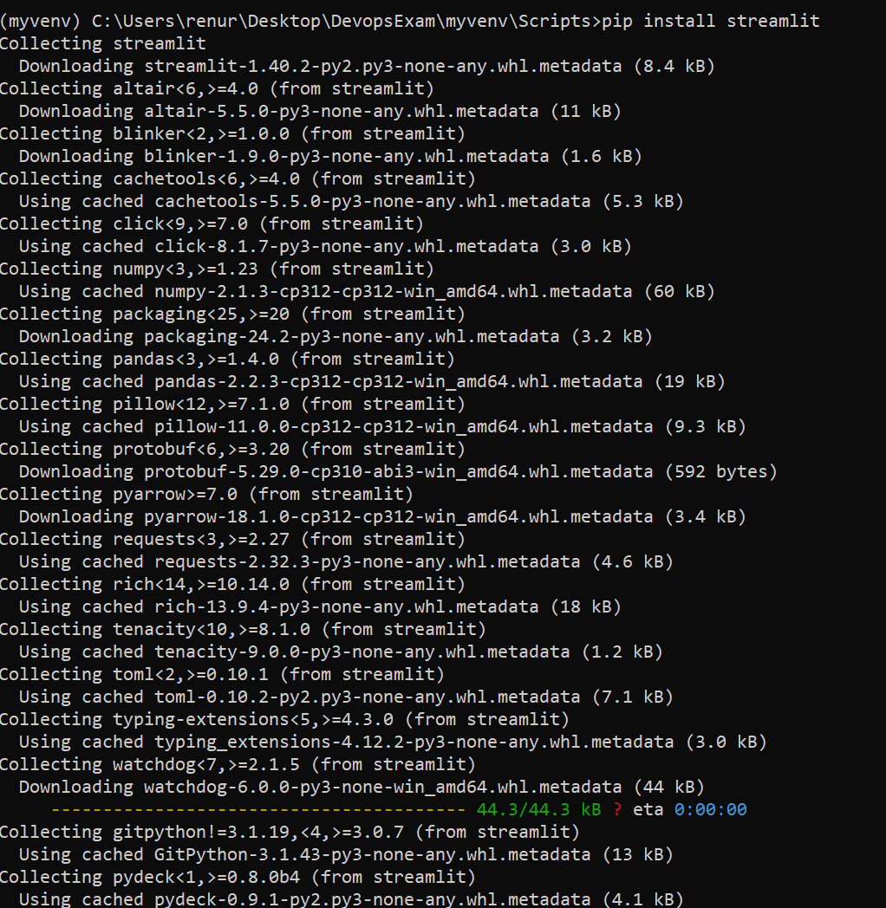

streamlit hello

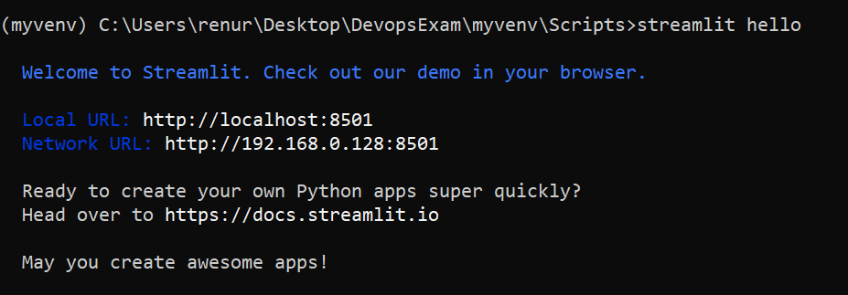

Open your myvenv folder in VSCode

Create a file named app.py

Write the following to create a very basic app:

import streamlit as st

import pandas as pd

import numpy as np

st.title('Hello App!')

Run the app using: streamlit run app.py

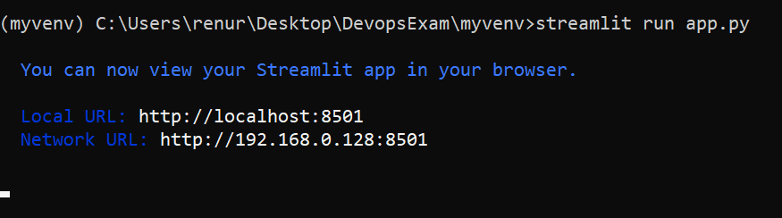

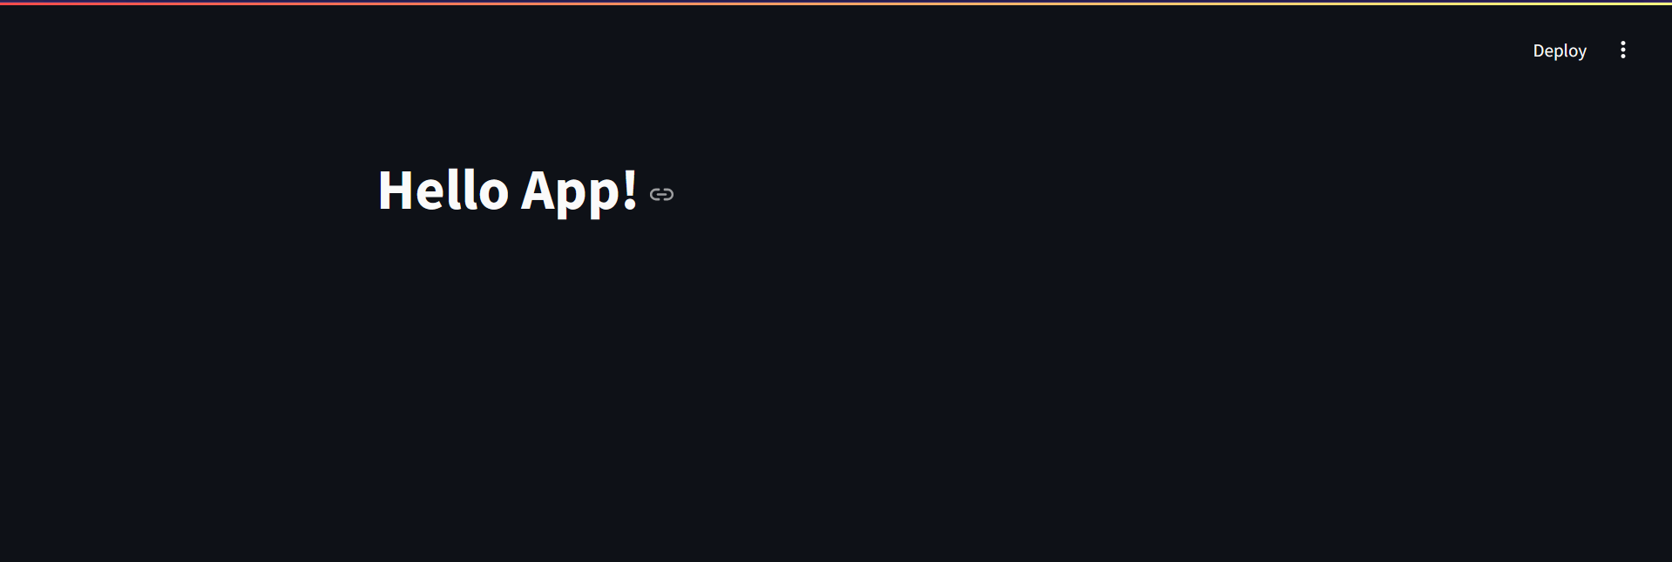

Add this code:

import streamlit as st

import pandas as pd

import numpy as np

st.title('Hello App!')

st.write(pd.DataFrame({

    'first column': [1, 2, 3, 4],

    'second column': [10, 20, 30, 40]

}))

Rerun the app

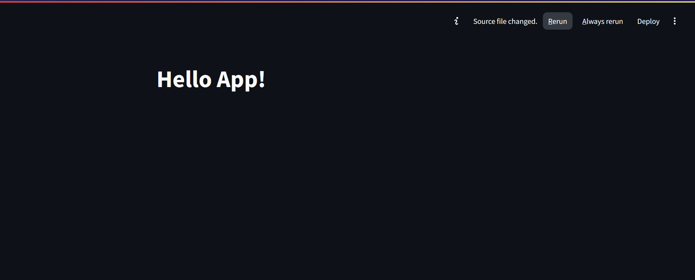

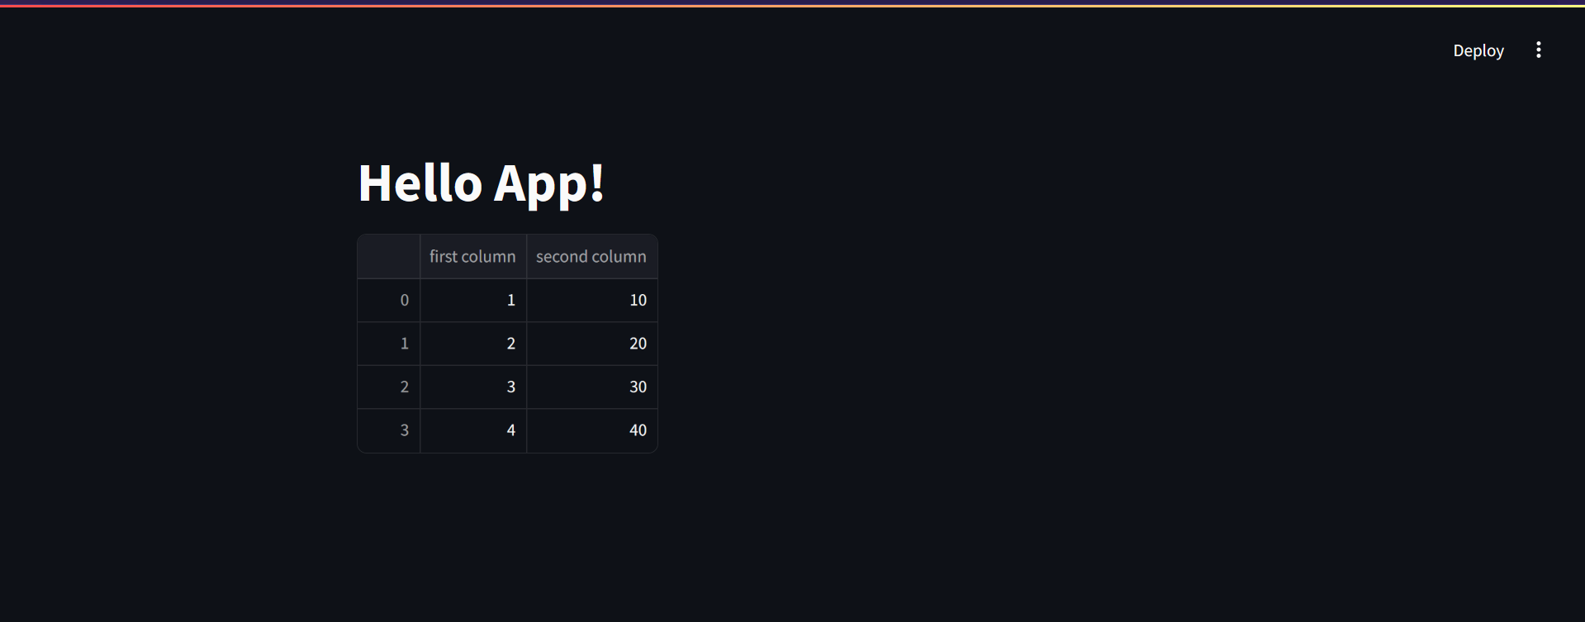

import streamlit as st

import pandas as pd

import numpy as np

st.title('Hello App!')

st.write(pd.DataFrame({

    'first column': [1, 2, 3, 4],

    'second column': [10, 20, 30, 40]

}))

df = pd.DataFrame({'Name': ['abc', 'xyz', 'pqr'], 'City': ['mumbai', 'delhi', 'pune']})

st.table(df)

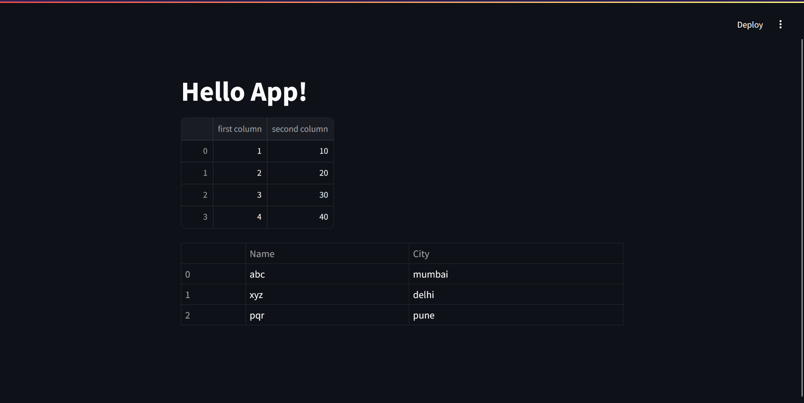

import streamlit as st

import pandas as pd

import numpy as np

st.title('Hello App!')

st.write(pd.DataFrame({

    'first column': [1, 2, 3, 4],

    'second column': [10, 20, 30, 40]

}))

df = pd.DataFrame({'Name': ['abc', 'xyz', 'pqr'], 'City': ['mumbai', 'delhi', 'pune']})

st.table(df)

chart_data = pd.DataFrame(

     np.random.randn(20, 3),

*columns*=['a', 'b', 'c'])

st.line_chart(chart_data)

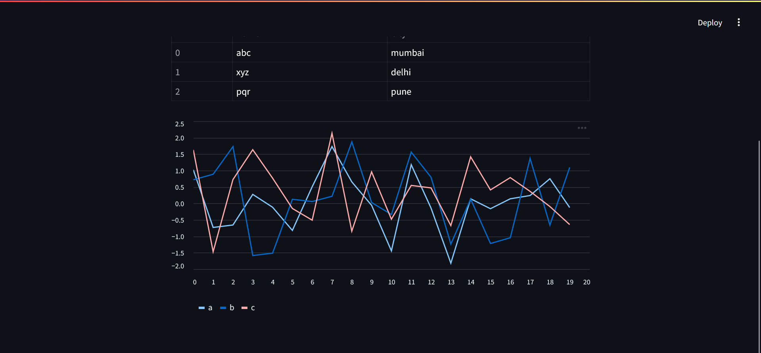

import streamlit as st

import pandas as pd

import numpy as np

st.title('Hello App!')

name = st.text_input('Enter your name:')

st.write('You entered: ', name)

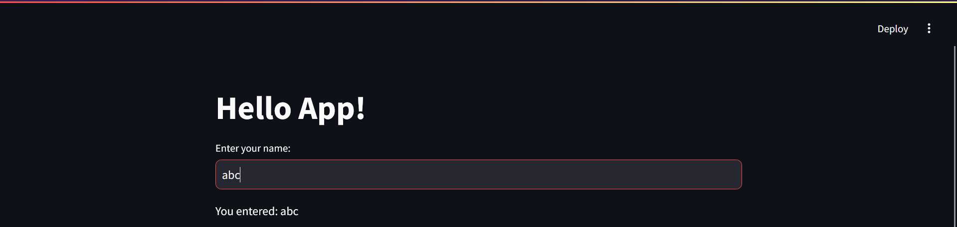

**With Api keys**

pip install python-dotenv

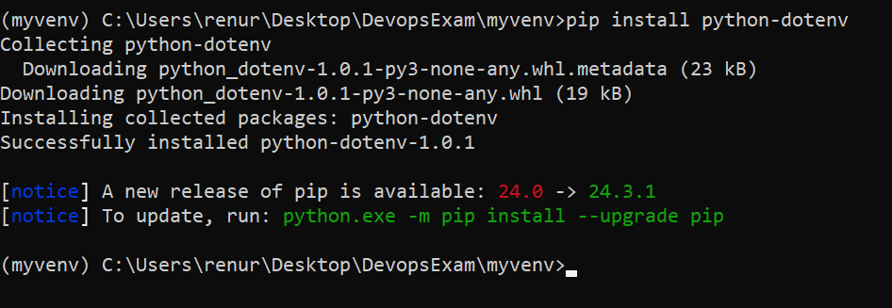

Create a file .env in your project folder

API_KEY=your_api_key_here

SECRET_KEY=your_secret_key_here

**Adding this project to GitHub and Streamlit cloud with ignoring the api keys**

Create a .gitignore file and add the **.env folder** in that file

*# Ignore the virtual environment folder*

*myvenv/*

*env/*

*# Ignore Python cache files*

*__pycache__/*

*\*.py[cod]*

*\*.pyo*

*# Ignore system files*

*.DS_Store*

*Thumbs.db*

*# Ignore IDE/editor-specific files*

*.vscode/*

*.idea/*

*\*.sublime-workspace*

*\*.sublime-project*

*# Ignore logs and temporary files*

*\*.log*

*\*.tmp*

*# Ignore configuration files and secrets*

***.env***

*# Ignore Jupyter Notebook checkpoints (if applicable)*

*.ipynb_checkpoints/*

*# Ignore compiled Python files*

*\*.pyc*

Initialize the repo

git init

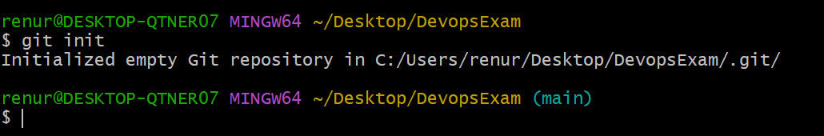

The .git folder has been created

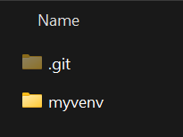

Get app.py and .gitignore and .env files outside the myvenv

Folder structure shld looks like this:

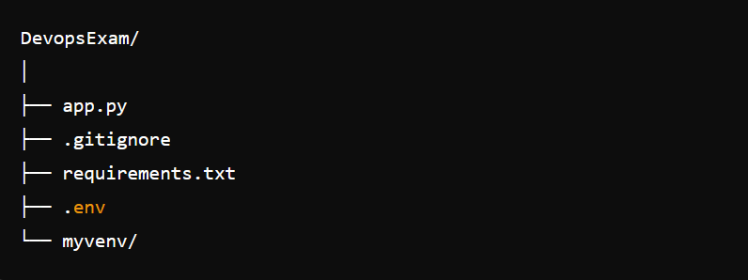

To ensure others can install the required dependencies, create a requirements.txt file:

pip freeze > requirements.txt

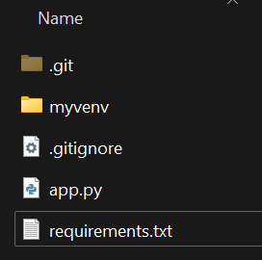

Then add the files you want to push to github

git add .

git status

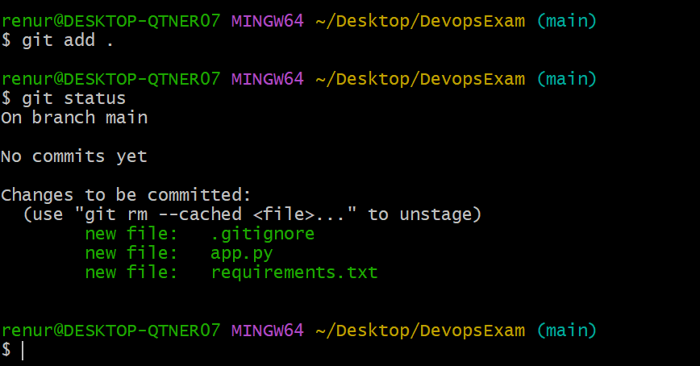

Create a new repo in github

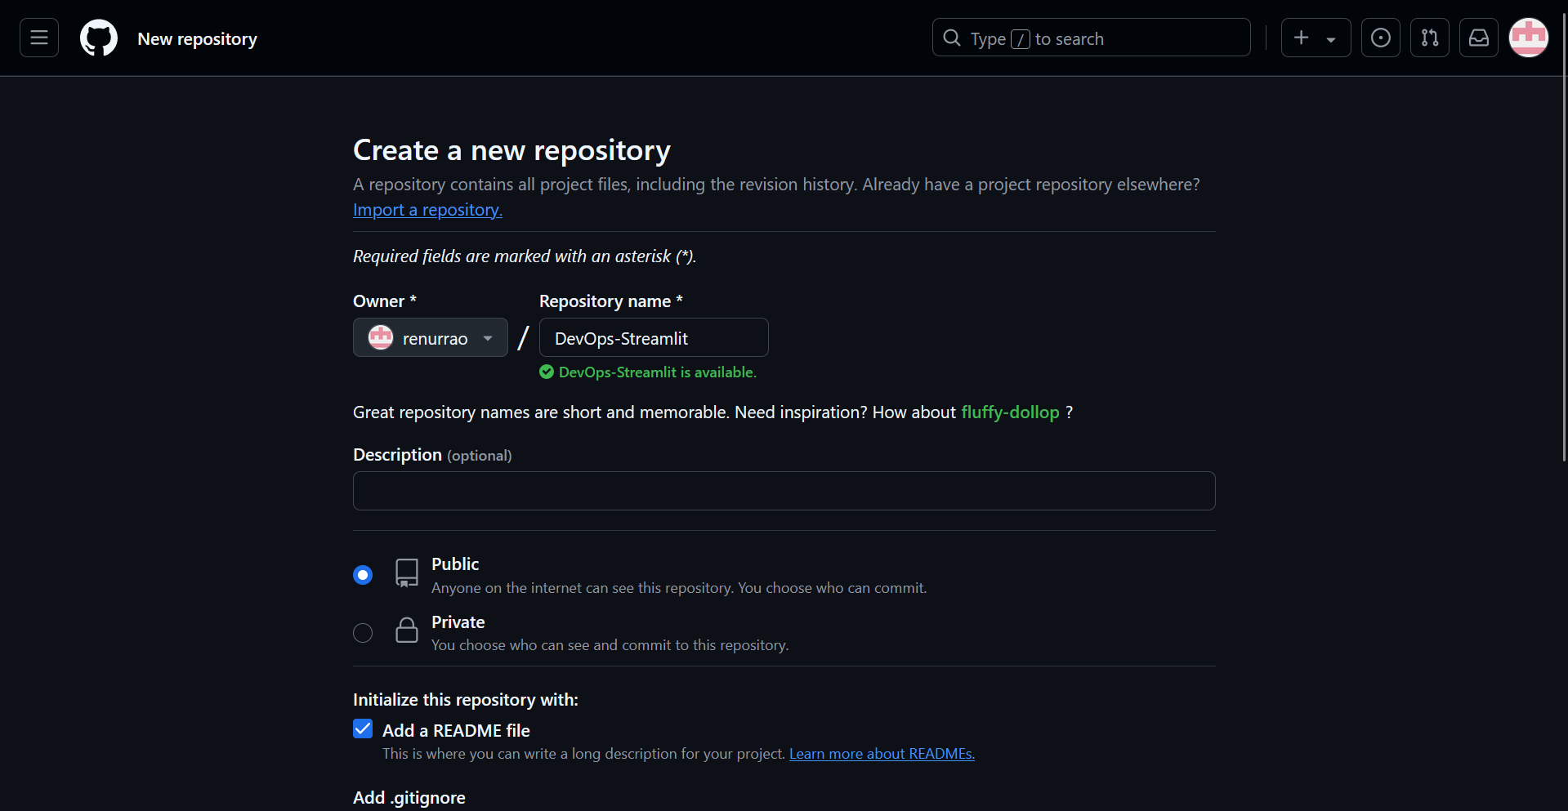

Get the url

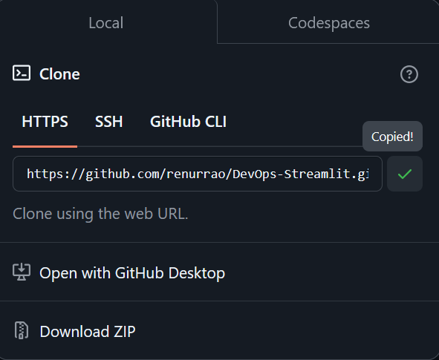

GitHub will show you commands to connect it to your local project:

Git remote add origin <<url of Github repo created>>

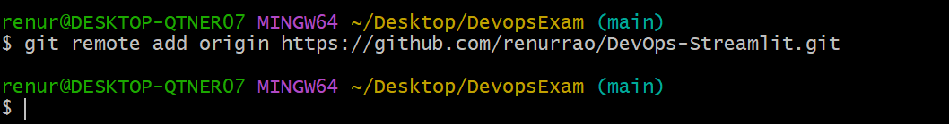

git remote -v

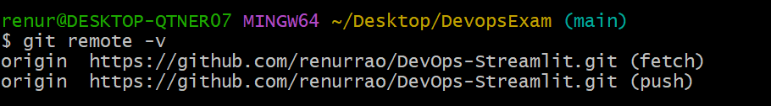

git commit -m ‘Streamlit Basic App’

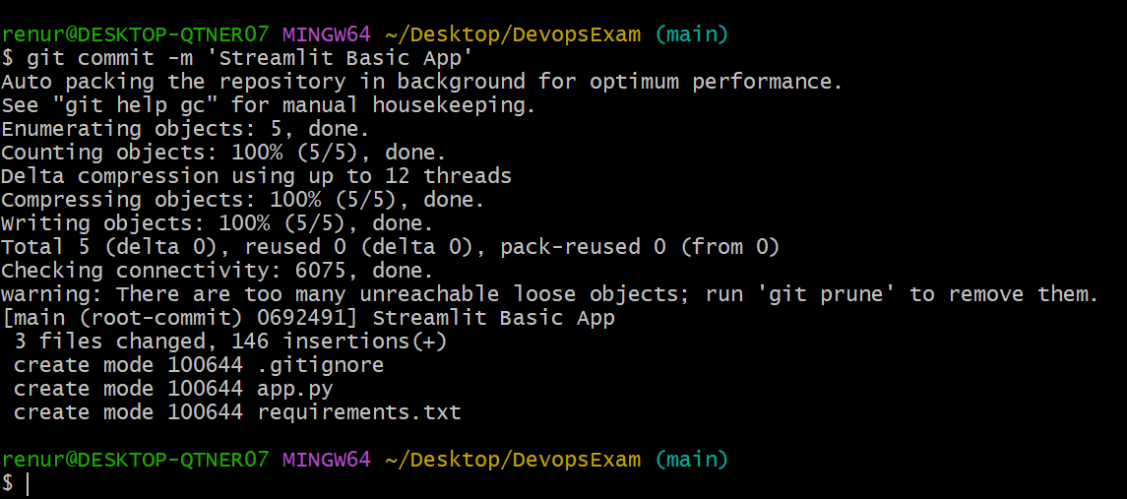

git remote add origin <https://github.com/renurrao/DevOps-Streamlit.git>

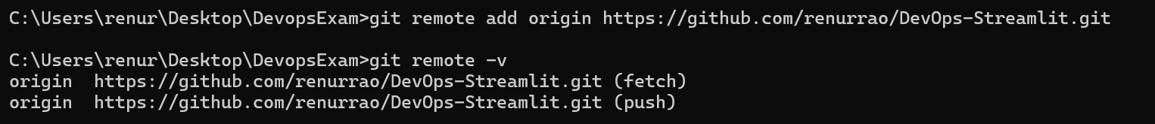

git push -u origin main

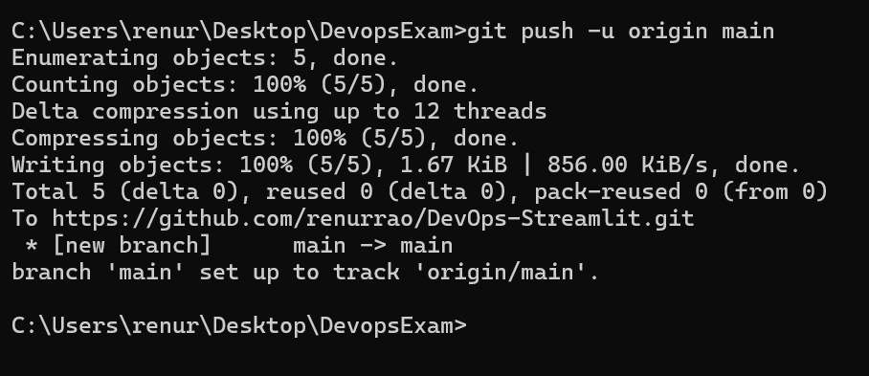

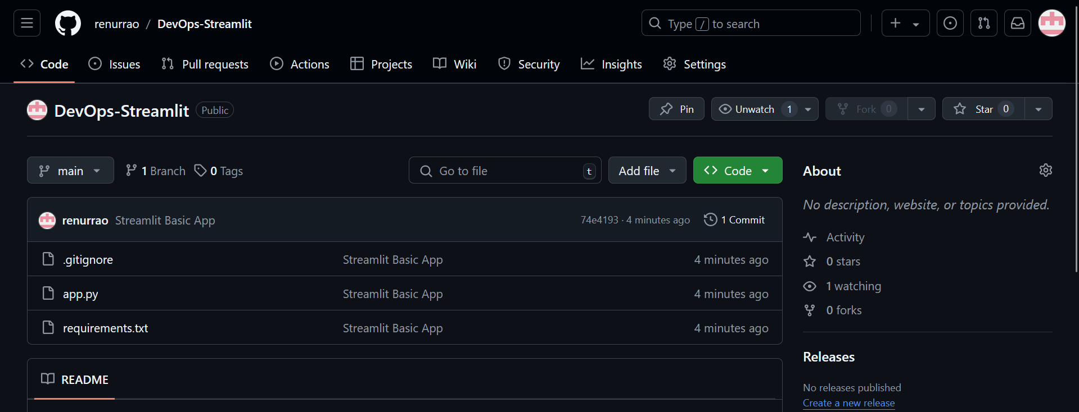

**Streamlit Cloud**

Sign up on Streamlit cloud with github

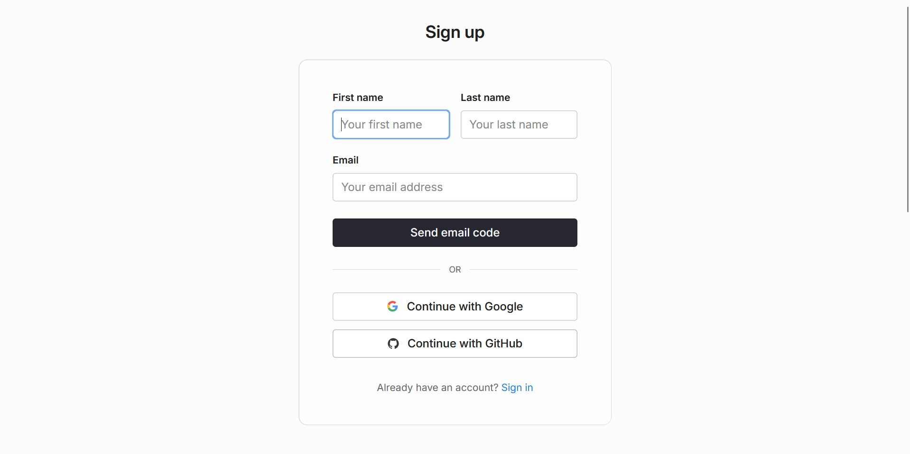Click authorize

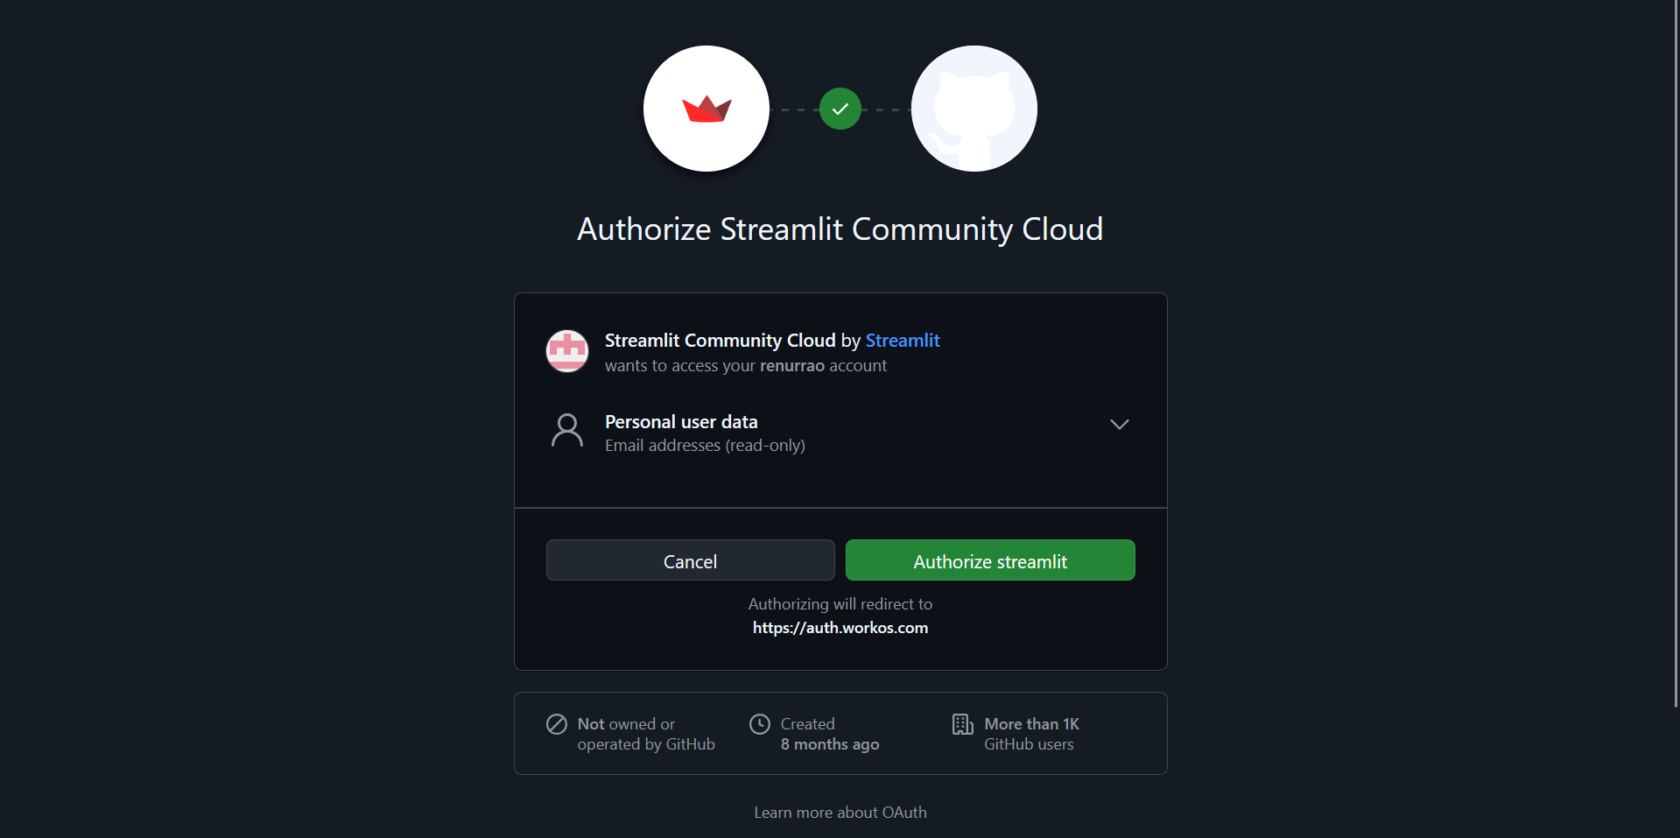

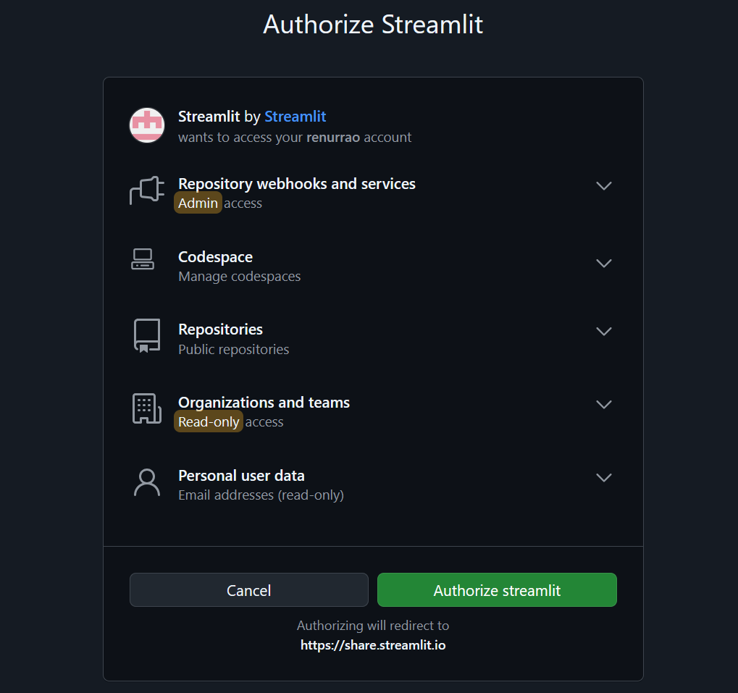

Fill in the necessary details to set up your account

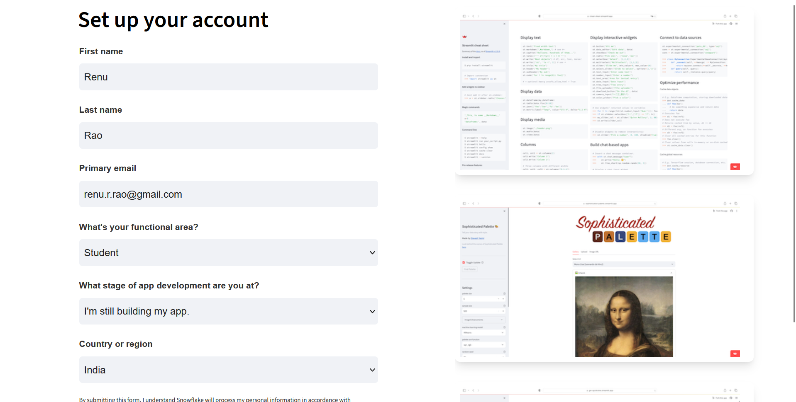

Click on create app

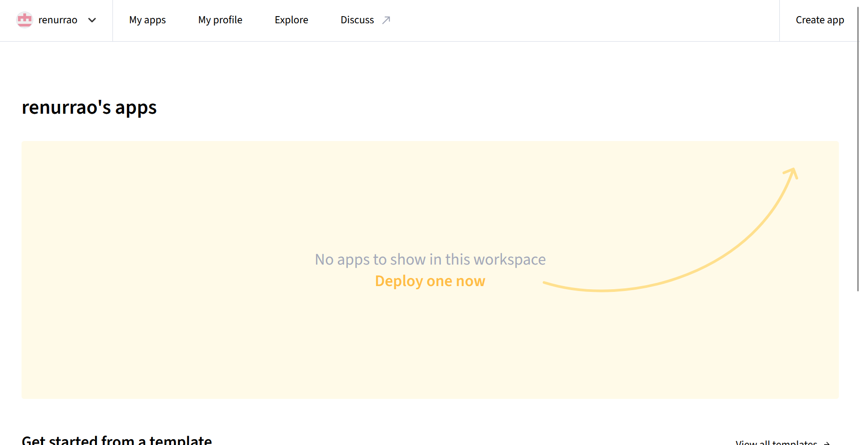

Deploy a public app from GitHub

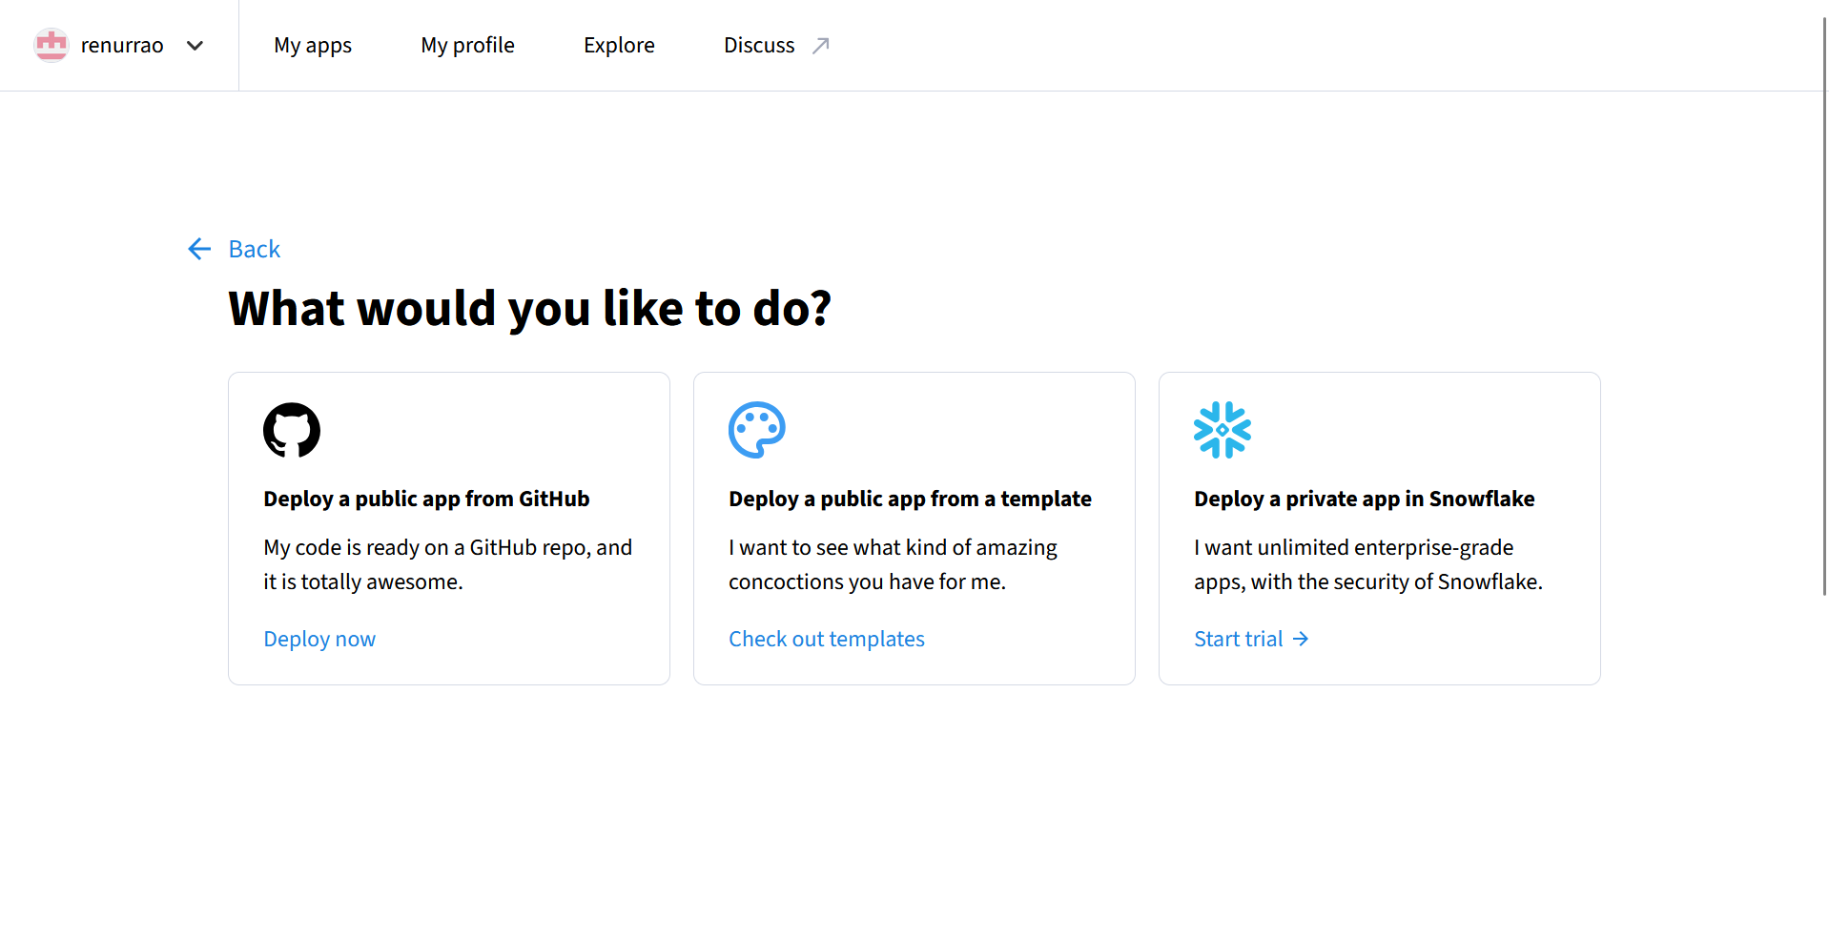

Select the proper repo, proper files and proper branch

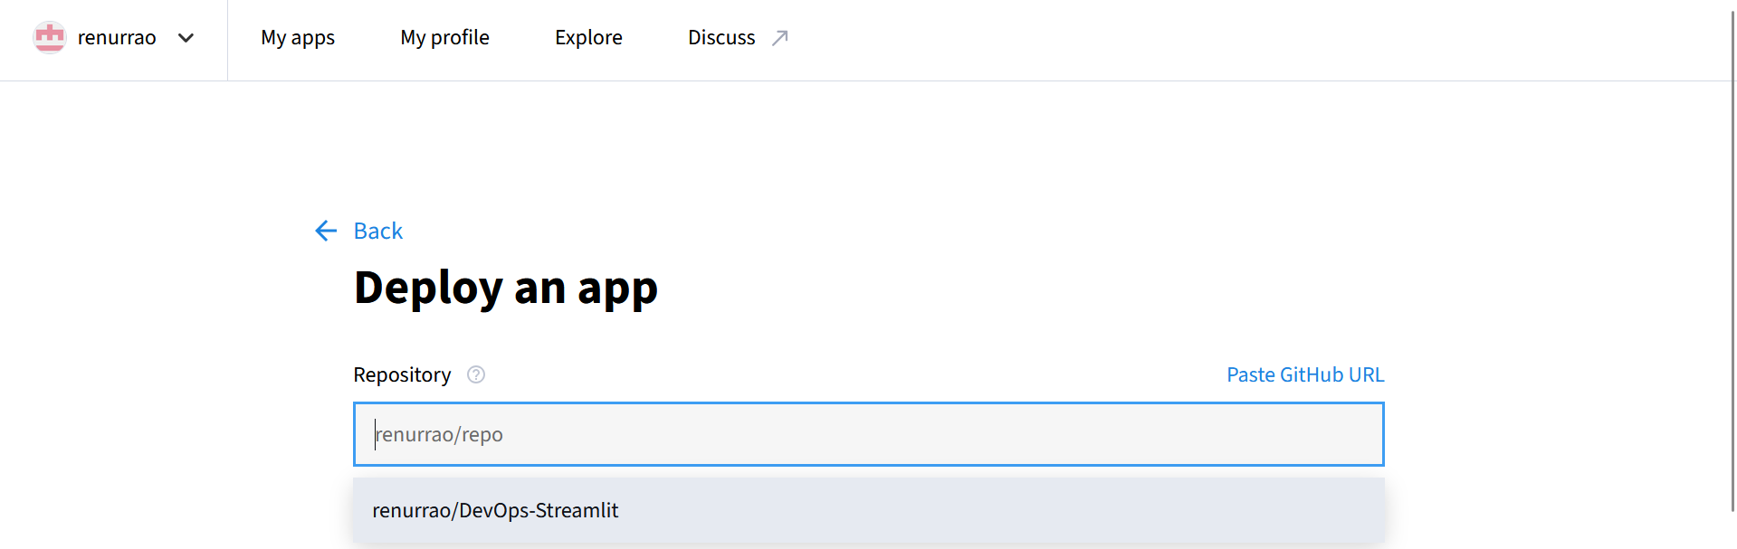

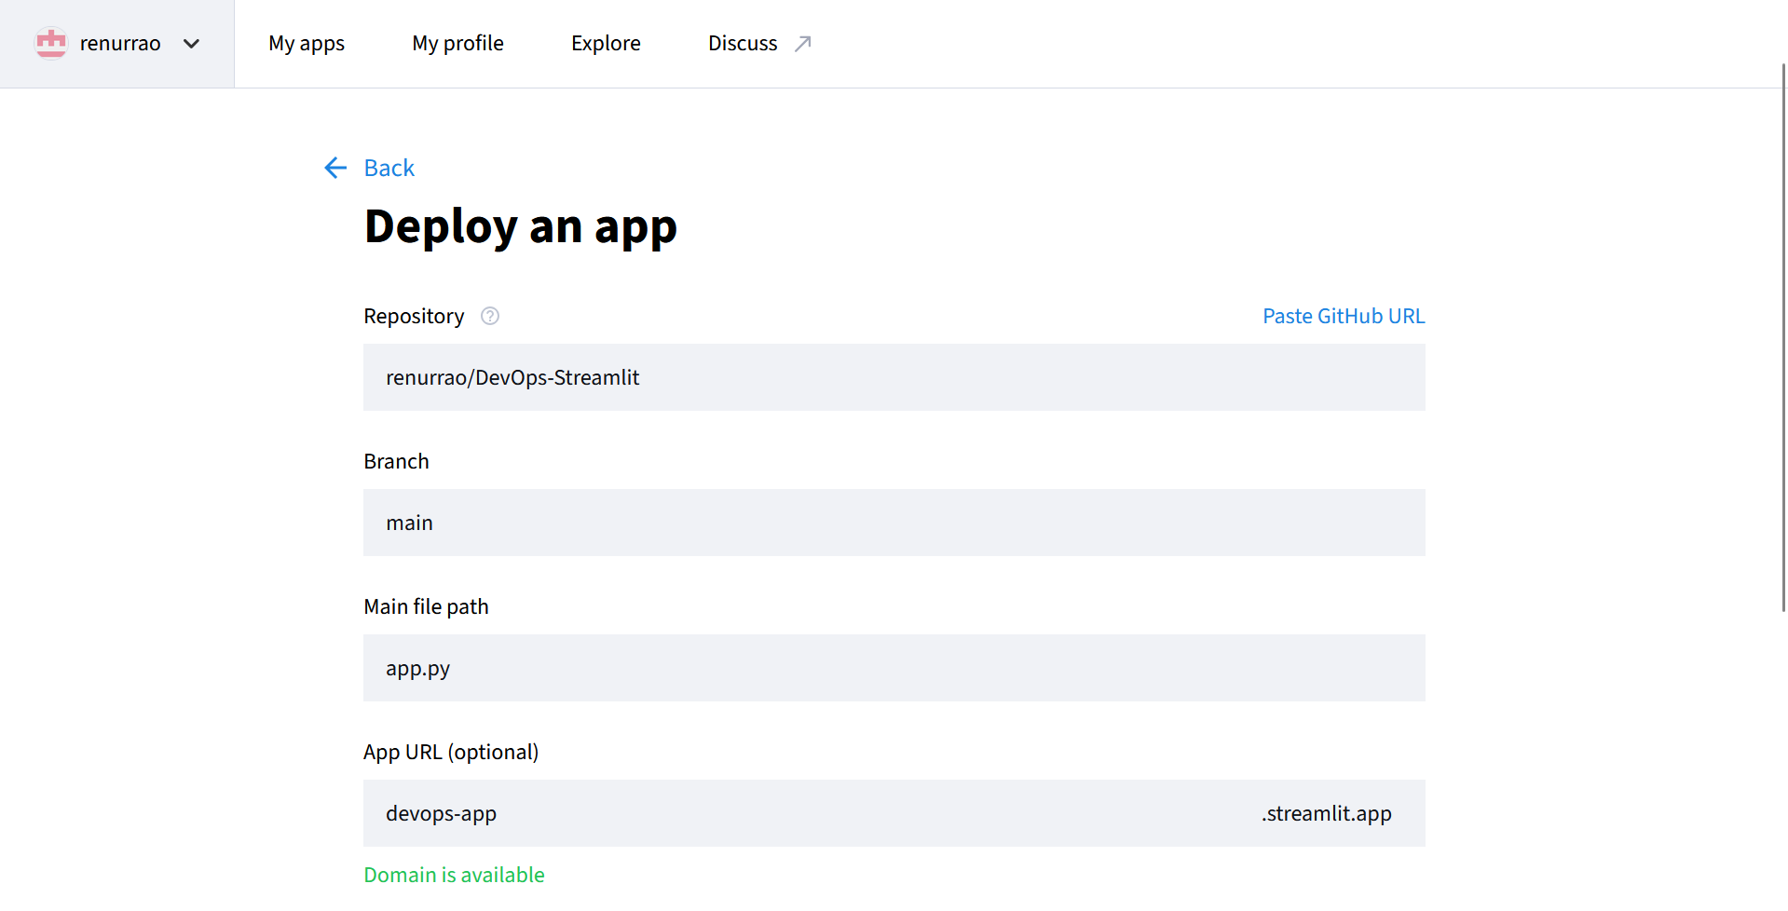

Deploy the app

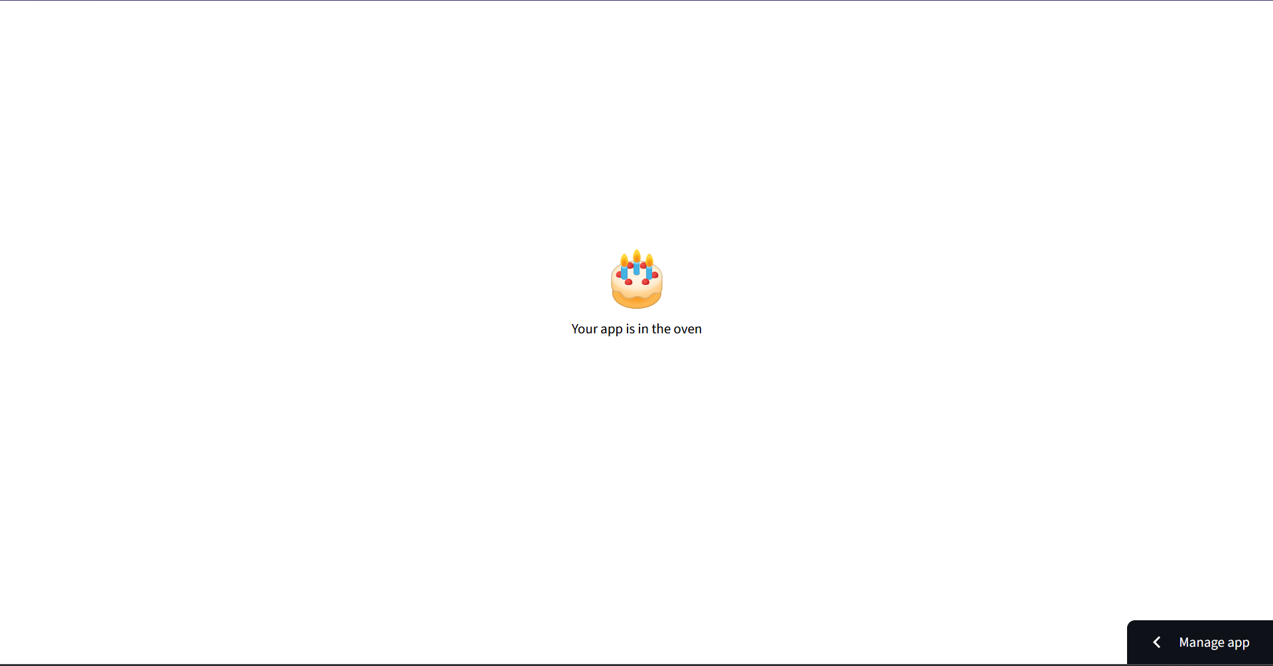

Deployed on Cloud

